Object Oriented Programming (IGS2130)

Lab 3

Student: Raykhonov Tilov ID:12225275

Instructor: Choonwoo Ryu, Ph.D

Exercise #1

#include <iostream>

using namespace std;

int main() {

int grade;

cout << "Enter your score of the exam: ";

cin >> grade; // Input variable for grade

if (grade >= 0 && grade < 60) {

cout << "Sorry. Your grade: F" << endl; //conditional statement for F

}

else if (grade >= 60 && grade < 70) {

cout << "Your grade: D" << endl;//conditional statement for D

}

else if (grade >= 70 && grade < 80) {

cout << "Your grade: C" << endl;//conditional statement for C

}

else if (grade >= 80 && grade < 90) {

cout << "Your grade: B" << endl;//conditional statement for B

}

else if (grade >= 90 && grade < 101) {

cout << "Congratulations!!! Your grade: A" << endl;//conditional statement for A

}

else {

cout << "You entered wrong input, sorry!"; //conditional statement for wrong input

}

}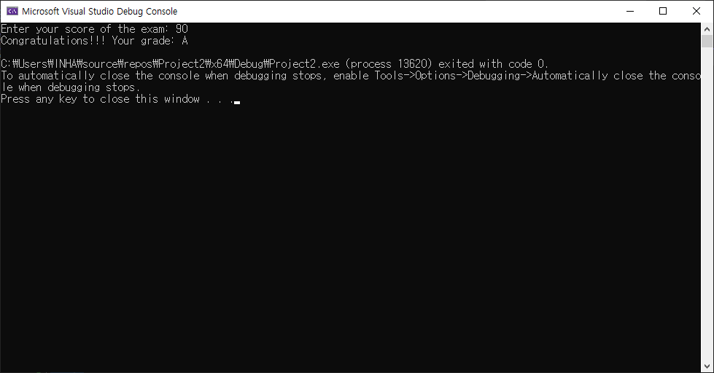

Exercise #2

#include <iostream>

using namespace std;

// function prototype

void display(char x);

void display(int a);

void display(double b);

int main() {

// function call

display('a');

display(1234);

display(123.4);

return 0;

}

//function definition

void display(char x) {

cout << "Char type: " << x << endl;

}

void display(int a) {

cout << "Int type: " << a << endl;

}

void display(double b) {

cout << "double type: " << b;

}

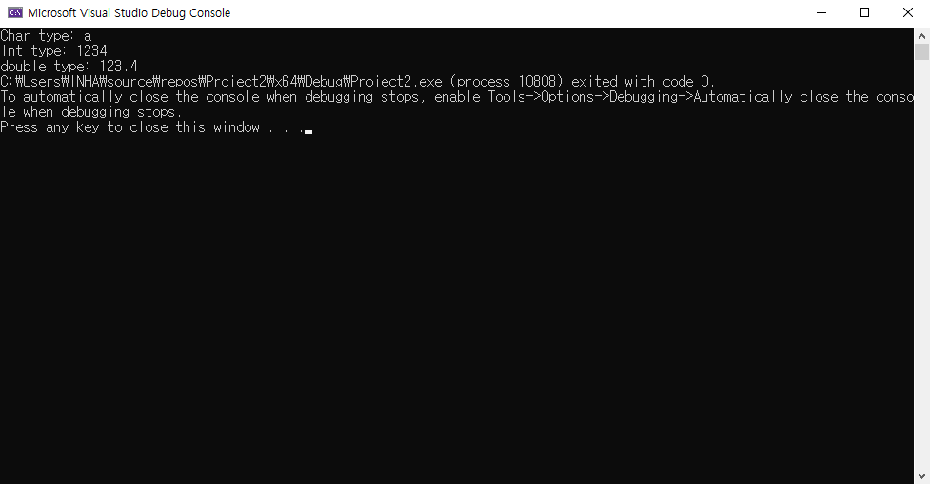

Exercise #3

#include <iostream>

using namespace std;

int main() {

int x;

int m = INT_MIN;

int mx = INT_MAX;

cout << "Type an integer number:";

cin >> m;

for (int i = 1; i < 10; i++) {

cout << "Type an integer number:";

cin >> x;

if (x > m)

m = x;

if (x < mx)

mx = x;

}

cout << "The maximum number you typed is " << m << endl;

cout << "The minimum number you typed is " << mx;

return 0;

}

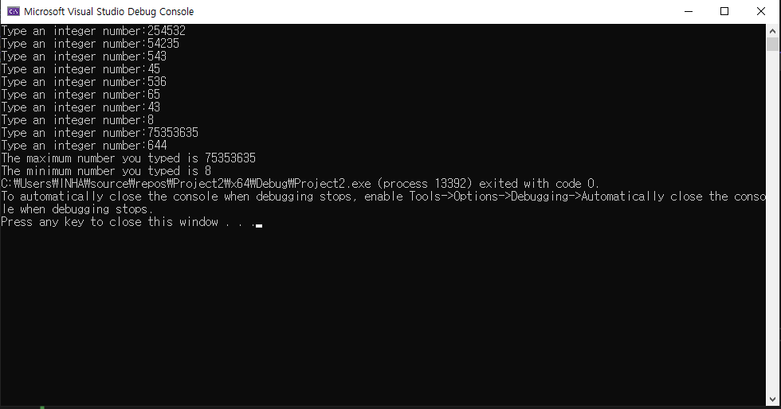

Exercise #4

#include <iostream>

using namespace std;

int GetMaximum(int numbers[], int* size) {

int max = numbers[0];

for (int i = 1; i < *size; i++) {

if (numbers[i] > max) {

max = numbers[i];

}

}

return max;

}

int GetMinimum(int numbers[], int* size) {

int min = numbers[0];

for (int i = 1; i < *size; i++) {

if (numbers[i] < min) {

min = numbers[i];

}

}

return min;

}

int main() {

int size;

cout << "Enter the # of numbers you want to input: ";

cin >> size;

double avg = 0;

double sum = 0;

int* numbers = new int[size];

for (int i = 0; i < size; i++) {

cout << i + 1 << "Input an integer: ";

cin >> numbers[i];

sum += numbers[i];

}

avg = sum / size;

cout << "Minimum value is: " << GetMinimum(numbers, &size) << endl;

cout << "Maximum value is: " << GetMaximum(numbers, &size) << endl;

cout << "Average value is: " << avg << endl;

delete[]numbers;

numbers = NULL;

return 0;

}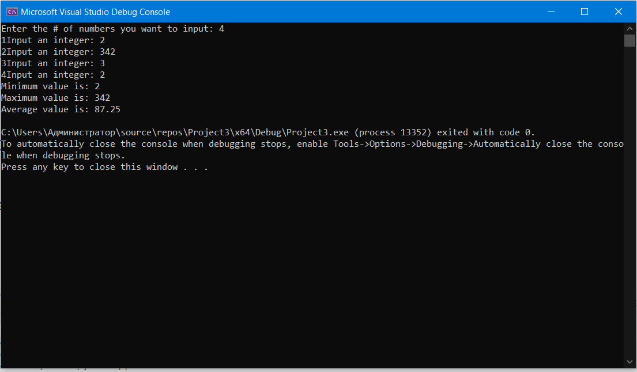

Exercise #5

#define _USE_MATH_DEFINES

#include <cmath>

#include <iostream>

using namespace std;

namespace shape {

int rec_area(int W, int L) {

return W * L;

}

int tri_area(int b, int h) {

return b * h / 2;

}

double cir_area(int r) {

double result =M_PI * r * r;

return result;

}

}

int main() {

cout << "Area of Rectangle(W:20, L:10):";

cout << shape::rec_area(20, 10) << endl;

cout << "Area of Triangle(b:20, h:10):";

cout << shape::tri_area(20, 10) << endl;

cout << "Area of Circle(r:20):";

cout << shape::cir_area(20) << endl;

return 0;

}

